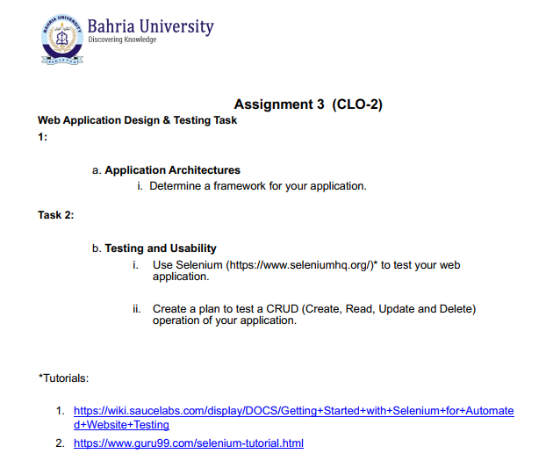
Instructions:
- Deadline: 10 May 2026 (softcopy - LMS)
- Bring hard copy along on 11 May 2026 for viva.
- Make sure the report has your Names and Enrollment numbers.

NO LATE SUBMISSIONS WILL BE ACCEPTED!

